Task 1:
S3 Bucket create and Blocked public Ips
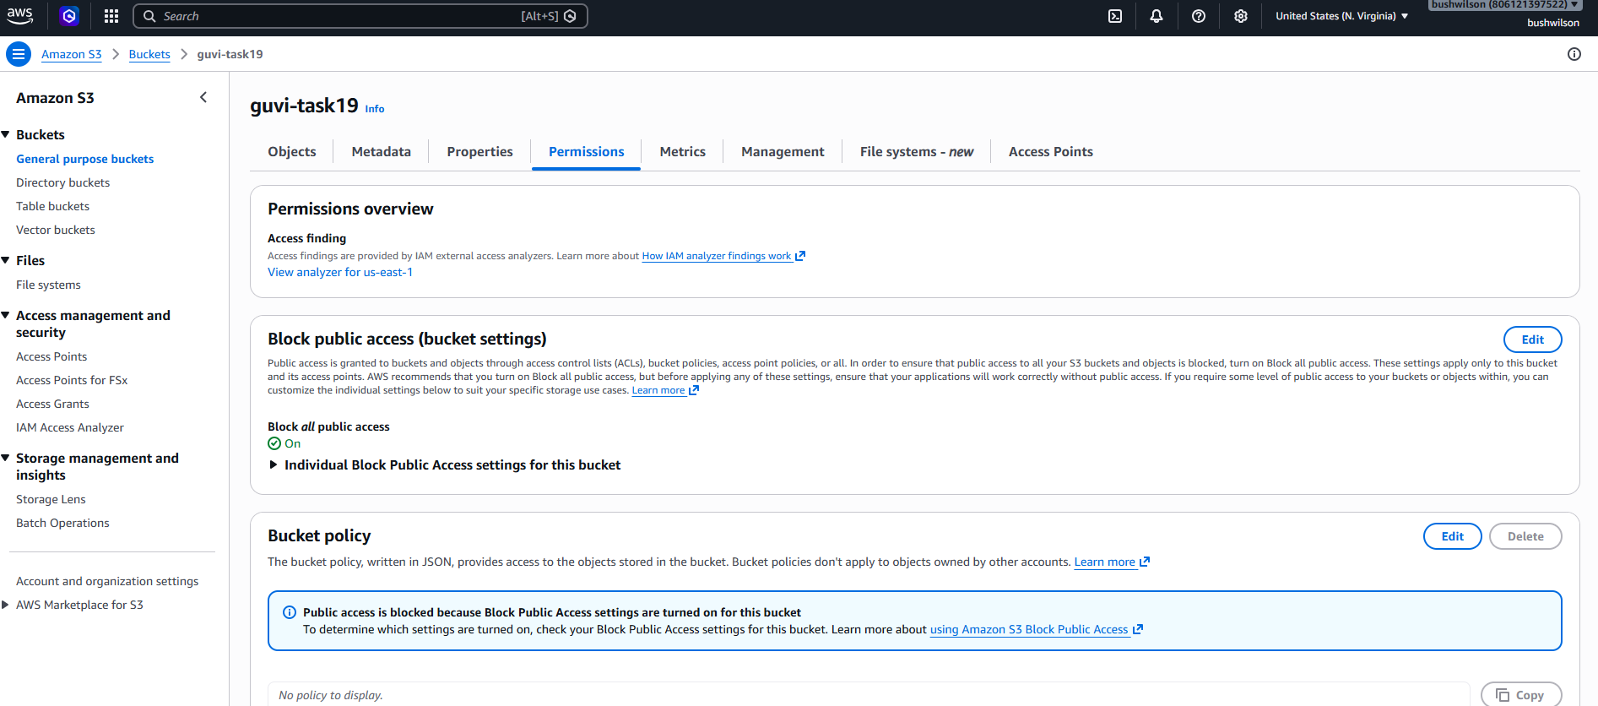
File uploaded (March 2026.pdf)
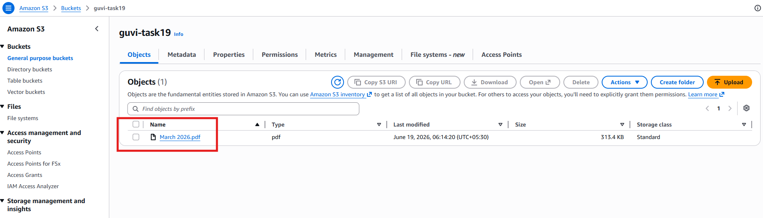
CloudTrail Created
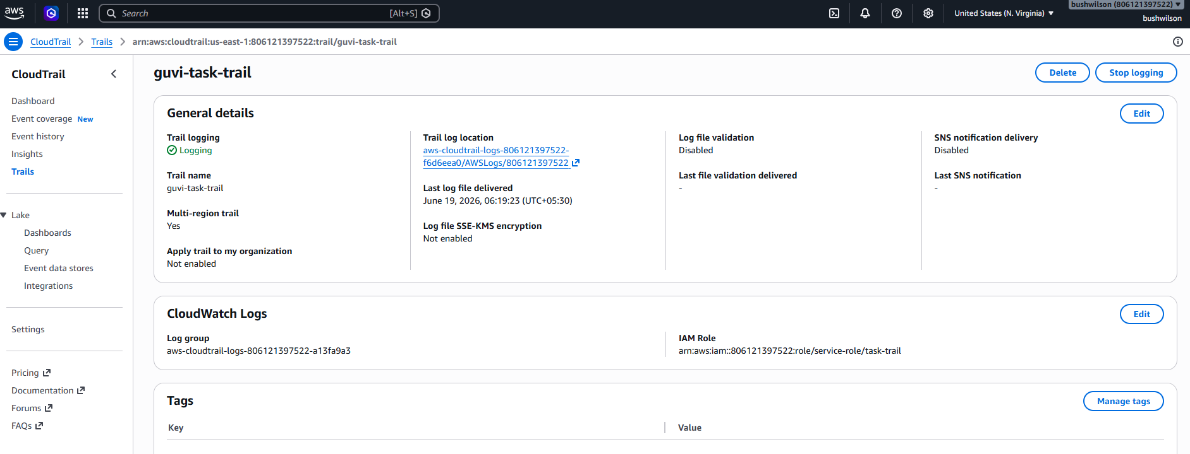

Logs from CloudWatch
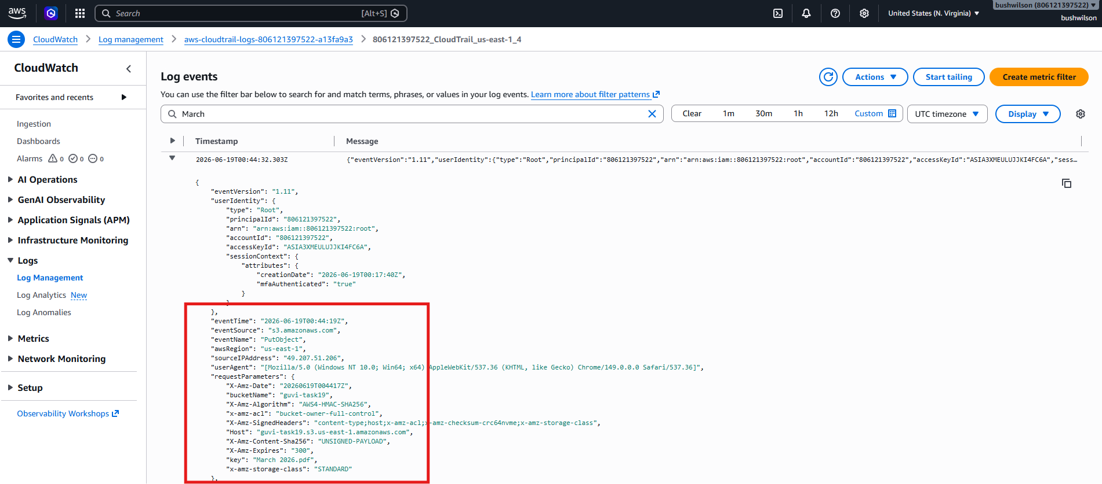
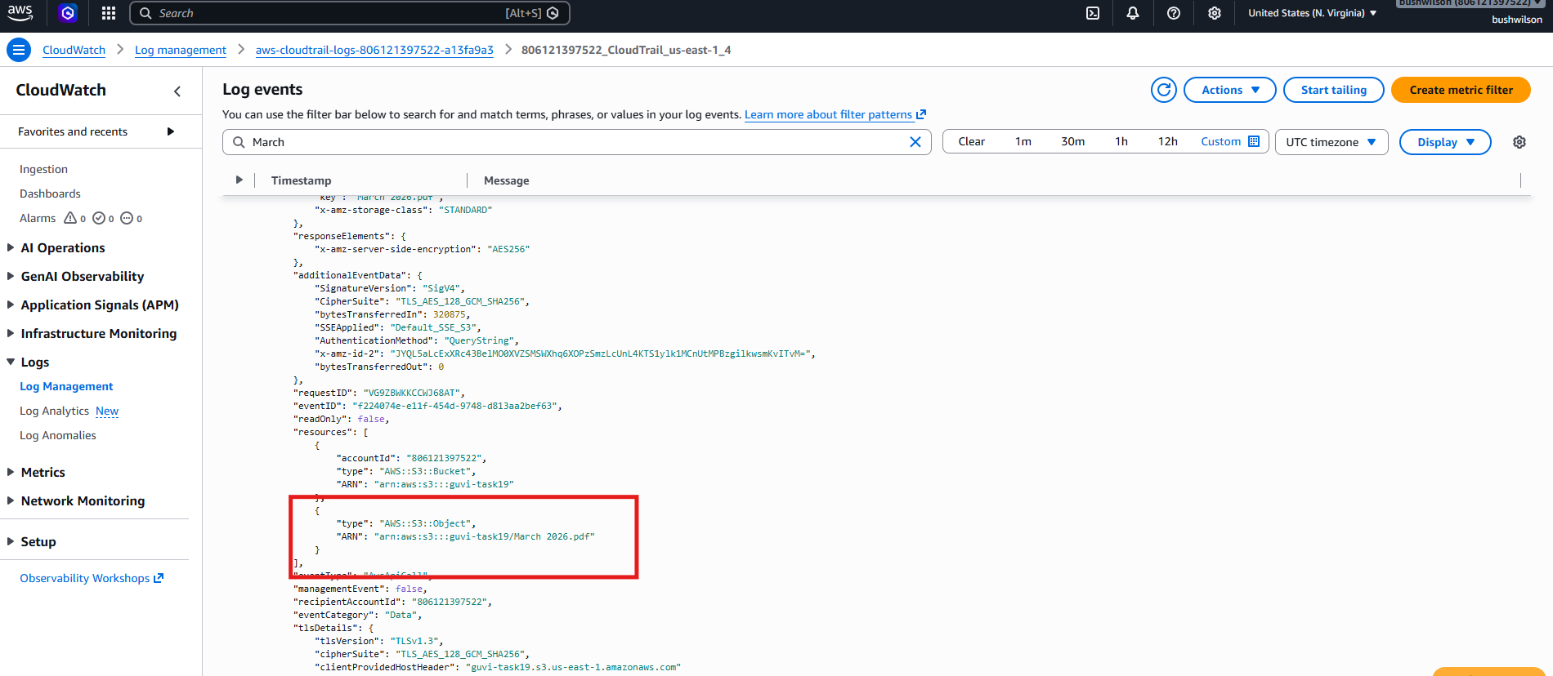

Task: 2
VPC Created
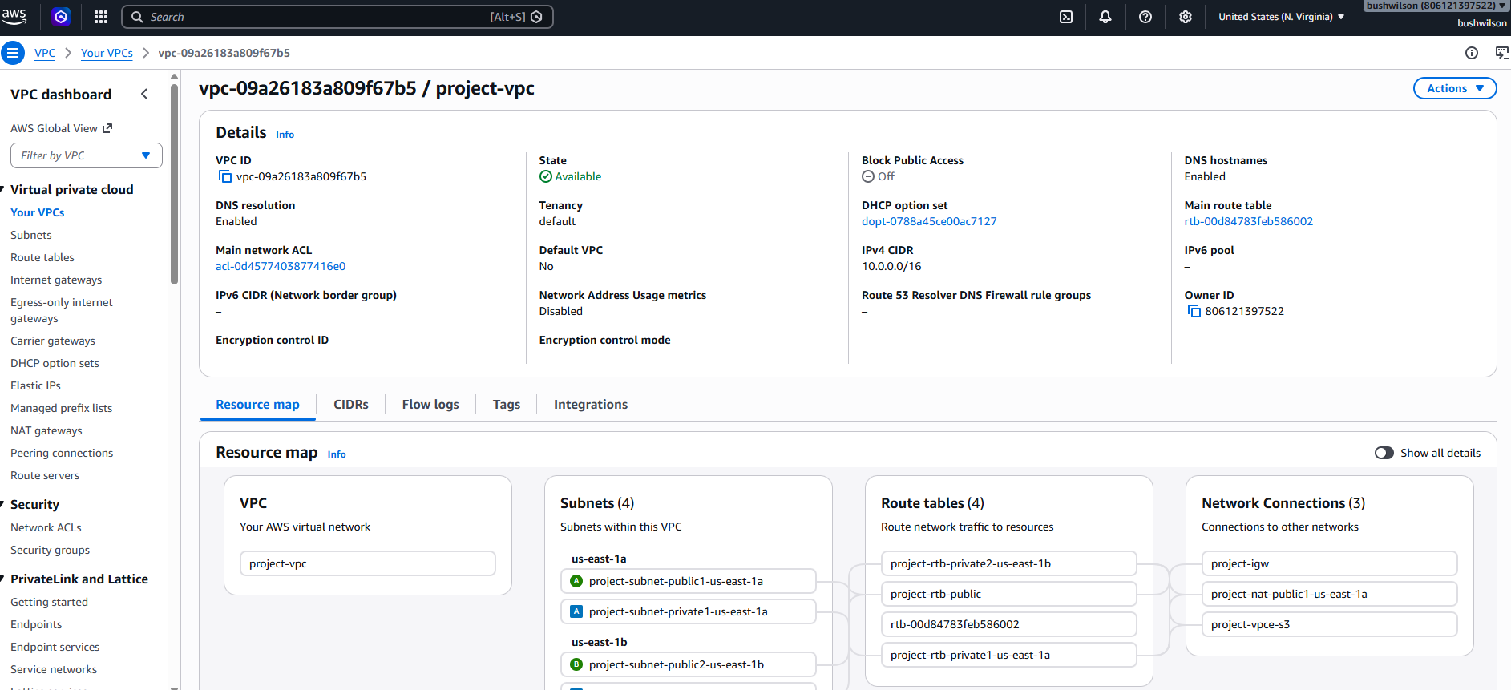
EC2 Instances Created
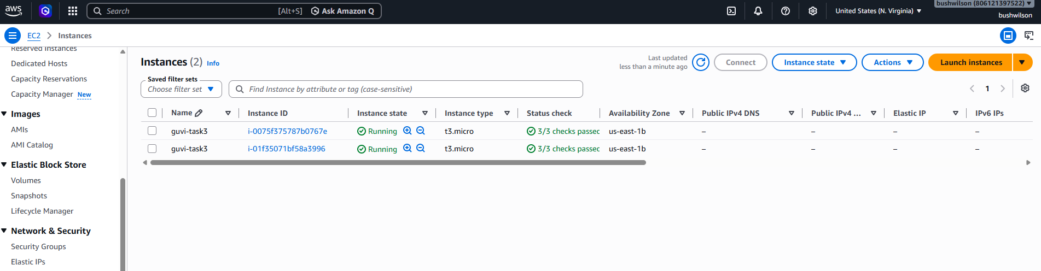
Target group created
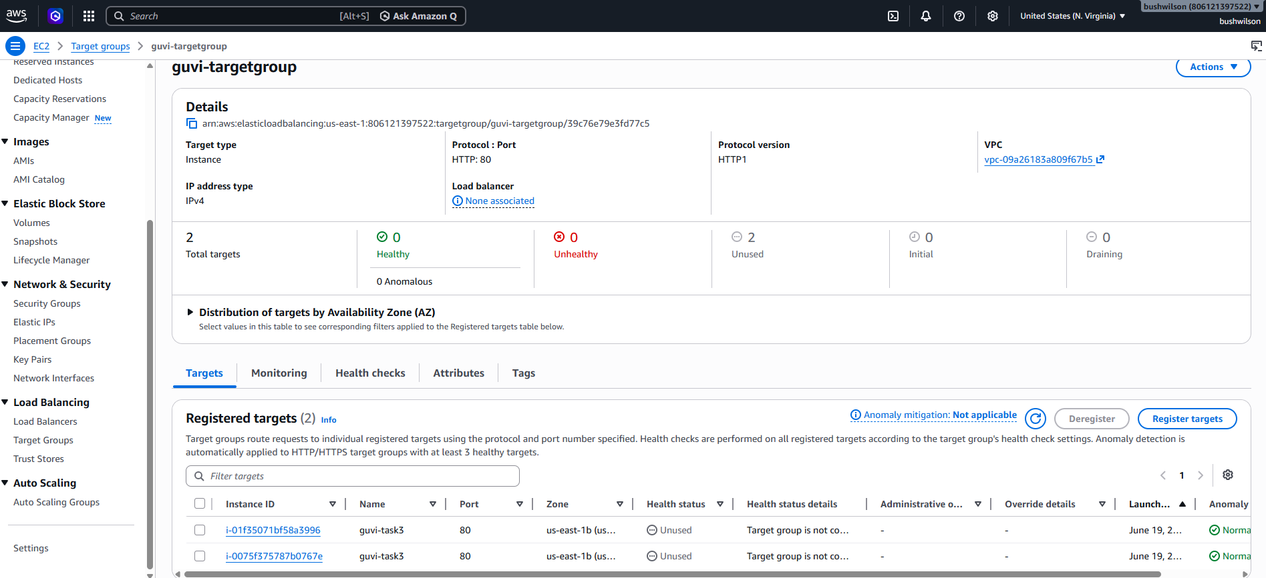

Load balancers created
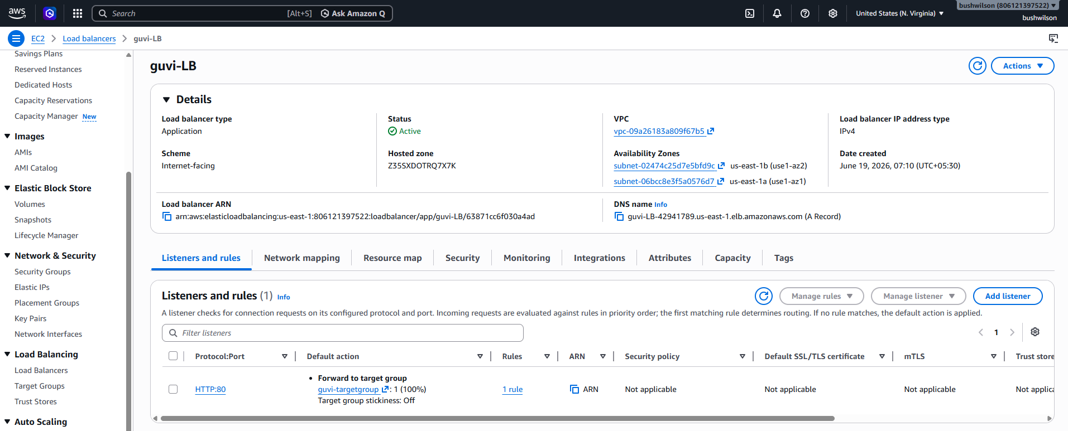
Message from alternate server
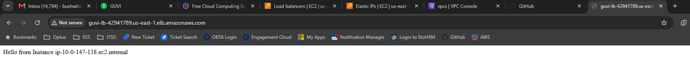
Elastic IPs
